Case Study Report

Data Analytics with Power BI

**“Inventory and sales analysis of**

**Departmental Store”**

**“Shri Nehru Maha Vidyalaya College of Arts and Science”**



**Tech Saksham**

|  |  |
| --- | --- |
| **NM ID** | **NAME** |
| **3821FC88E88355ABC074FE22FA67AC1E** | **VARNAN S** |

Trainer Name: R UMAMAHESWARI

Master Trainer: R UMAMAHESWARI

# ABSTRACT

Departmental stores play a pivotal role in retail operations, offering a diverse range of products to consumers. Effective management of inventory and sales within these stores is crucial for optimizing profitability and ensuring customer satisfaction. This study presents a comprehensive analysis of inventory and sales data collected from departmental stores, focusing on understanding the dynamics of product movement, identifying trends, and uncovering actionable insights. Various analytical techniques such as trend analysis, correlation analysis, and inventory turnover ratios are employed to examine the relationships between inventory levels, sales performance, and other relevant factors. The findings shed light on factors influencing inventory management decisions and sales strategies, including seasonality, product popularity, and promotional activities. Additionally, the study explores the impact of technological advancements and data-driven approaches on inventory optimization and sales forecasting within departmental stores. The insights gained from this analysis contribute to enhancing operational efficiency, improving inventory management practices, and maximizing revenue generation in departmental store settings.



## INDEX

|  |  |  |
| --- | --- | --- |
| **Sr. No.** | **Table of Contents** | **Page No.** |
| 1 | Chapter 1: Introduction | 1 |
| 2 | Chapter 2: Services and Tools Required | 3 |
| 3 | Chapter 3: Project Architecture | 4 |
| 4 | Chapter 4: Modelling and Result | 6 |
| 5 | Conclusion | 13 |
| 6 | Future Scope | 14 |
| 7 | References | 15 |
| 8 | Links | 16 |



**CHAPTER 1**

## INTRODUCTION

### 1.1 Problem Statement

The problem statement revolves around the intricate task of efficiently managing inventory and optimizing sales performance in departmental stores. Balancing adequate inventory levels with maximizing sales and profitability presents a multifaceted challenge, encompassing inventory management, sales optimization, gross margin enhancement, and variance analysis. This entails navigating complexities such as stock adequacy, customer preferences, pricing strategies, and operational efficiency. Tackling these challenges necessitates leveraging advanced technologies and analytical tools to glean actionable insights, enabling departmental stores to adapt, innovate, and thrive in a competitive retail environment.

### 1.2 Proposed Solution

The proposed solution merges state-of-the-art inventory management software with meticulously crafted sales tactics to not only fine-tune stock levels and amplify sales but also to elevate gross margins. By harnessing predictive analytics and granular customer insights, alongside proactive cost controls and exhaustive variance analysis, departmental stores can streamline operations, fortify profitability, and swiftly adapt to the dynamic nuances of the retail ecosystem. This comprehensive strategy fosters operational excellence, resilience, and enduring prosperity amidst the relentless competition of the retail landscape.

### 1.3 Feature

* Advanced Inventory Management: Implementing sophisticated software capable of accurately forecasting demand, optimizing stock levels, and automating inventory replenishment processes.
* Data-Driven Sales Strategies: Utilizing analytics to gain insights into customer behavior, purchasing patterns, and product performance, enabling tailored marketing campaigns, pricing strategies, and promotions.
* Gross Margin Optimization: Employing proactive measures to enhance gross margin through cost management, pricing optimization, and promotional efficiency analysis.
* Variance Analysis Tools: Establishing robust processes for analyzing discrepancies between forecasted and actual sales, as well as deviations in inventory levels, to identify areas for improvement and inform decision-making.

### 1.4 Advantages

* Improved Efficiency: By streamlining inventory management processes and leveraging data-driven insights, departmental stores can operate more efficiently, reducing waste and optimizing resource utilization.
* Increased Sales: Through targeted marketing campaigns, personalized promotions, and optimized pricing strategies, the solution helps boost sales by catering to the specific needs and preferences of customers.
* Enhanced Profitability: By optimizing inventory levels, minimizing costs, and maximizing gross margins, departmental stores can improve profitability and financial performance.

### 1.5 Scope

The scope of the proposed solution encompasses the comprehensive optimization of inventory management and sales strategies within departmental stores, utilizing advanced technologies and data-driven insights to enhance operational efficiency, boost sales, and improve profitability. This includes implementing sophisticated inventory management software, leveraging predictive analytics for demand forecasting, refining pricing and promotional strategies based on customer insights, and establishing robust processes for variance analysis and continuous improvement. The solution aims to address key challenges faced by departmental stores, offering a holistic approach to drive sustainable growth and competitive advantage in the retail industry.

## CHAPTER 2

## SERVICES AND TOOLS REQUIRED

### 2.1 Services Used

1. Inventory Management Software: Sophisticated software solutions for forecasting demand, optimizing stock levels, and automating inventory replenishment processes.
2. Data Analytics: Advanced analytics tools for gaining insights into customer behaviour, purchasing patterns, and product performance, enabling informed decision-making and targeted marketing efforts.
3. Predictive Analytics: Machine learning algorithms for dynamically adjusting inventory levels based on factors such as seasonality, trends, and sales forecasts, enhancing operational efficiency and reducing stockouts.
4. Business Intelligence (BI) Tools: BI platforms for visualizing and analyzing data from various sources, facilitating performance monitoring, trend analysis, and actionable insights generation.

### 2.2 Tools and Software used

**Tools**:

* **PowerBI**: The main tool for this project is PowerBI, which will be used to create interactive dashboards for real-time data visualization.
* **Power Query**: This is a data connection technology that enables you to discover, connect, combine, and refine data across a wide variety of sources.

**Software Requirements**:

* **PowerBI Desktop**: This is a Windows application that you can use to create reports and publish them to PowerBI.
* **PowerBI Service**: This is an online SaaS (Software as a Service) service that you use to publish reports, create new dashboards, and share insights.
* **PowerBI Mobile**: This is a mobile application that you can use to access your reports and dashboards on the go.

## CHAPTER 3

## PROJECT ARCHITECTURE

### 3.1 Architecture

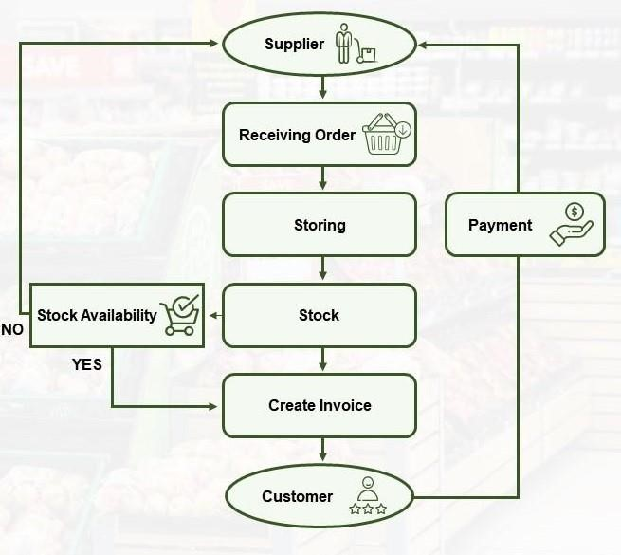

Here’s a high-level architecture for the project:

* Frontend Application:
  + Web Interface: Provides a user-friendly dashboard for accessing inventory and sales reports, managing products, and analysing data.
  + Mobile Application: Offers on-the-go access to key metrics and inventory management functionalities for store managers and employees.
* Backend Services:
  + Inventory Management Service: Manages inventory data, including product information, stock levels, and replenishment processes.
  + Sales Analysis Service: Analyses sales data, generates reports, and provides insights into sales performance, trends, and forecasting.
  + User Management Service: Handles user authentication, authorization, and access control for frontend applications.
* Database:
  + Transactional Database: Stores transactional data such as sales records, inventory transactions, and customer information. o Data Warehouse: Collects and stores historical data for analytics and reporting purposes, enabling long-term trend analysis and forecasting.
* Integration Layer:
  + API Gateway: Facilitates communication between frontend applications and backend services, enforcing security policies and rate limiting.
  + Message Broker: Handles asynchronous communication and event-driven architecture for real-time updates and notifications.
  + Third-Party Integrations: Integrates with external systems such as suppliers' databases, payment gateways, and CRM systems for seamless data exchange.
* Analytics and Reporting:
  + Data Analytics Engine: Utilizes tools and algorithms for data processing, cleansing, transformation, and analysis to derive actionable insights.
  + Reporting Module: Generates comprehensive reports, dashboards, and visualizations to present inventory and sales data in an understandable format for stakeholders.
* Security and Compliance:
  + Authentication and Authorization: Implements robust authentication mechanisms such as OAuth, JWT, or SAML, and role-based access control (RBAC) for secure access to data and functionalities.
  + Data Privacy and Compliance: Ensures compliance with data privacy regulations such as GDPR or CCPA by implementing data masking, encryption, and anonymization techniques.

## CHAPTER 4

## MODELING AND RESULT

### Manage relationship

1. Customer Engagement: Departmental stores can manage relationships with customers by offering personalized shopping experiences, providing excellent customer service, and actively seeking feedback to address their needs and preferences.
2. Supplier Collaboration: Establishing transparent communication channels, negotiating fair terms, and collaborating on initiatives to improve product quality and delivery efficiency strengthens relationships with suppliers, ensuring a reliable and efficient supply chain.
3. Employee Empowerment: Engaging employees through training and development opportunities, recognition programs, and fostering a positive work culture enhances job satisfaction and loyalty, leading to improved productivity and performance.
4. Business Partner Alignment: Maintaining clear communication, aligning goals and expectations, and adhering to contractual agreements with business partners such as marketing agencies and technology vendors fosters trust and collaboration, driving mutual success and innovation.

#### Database Design and Entity Relationship Diagram

Within the scope of this project, the total entities of the system are 10, ranging from SHOPPERS to ORDERS as well as WAREHOUSES and SUPPLIERS. Four primary entities include **ORDERS**, **SHOPPERS**, **PRODUCTS**, and **WAREHOUSES**, which carry fundamental information for the system baseline and meet the business queries from our major user profiles as stated above. There are two association entities inferred from these four foundation entities: **ITEM_ORDERS**, which provides the outflow of goods, and **ITEM_AVAILABILITIES**, which refers to stock on hand. The remaining entities are created to meet the Third Normal Form of data optimization such as **PRODUCT_CATEGORIES**, **SHIPPERS,** and **SUPPLIERS**.

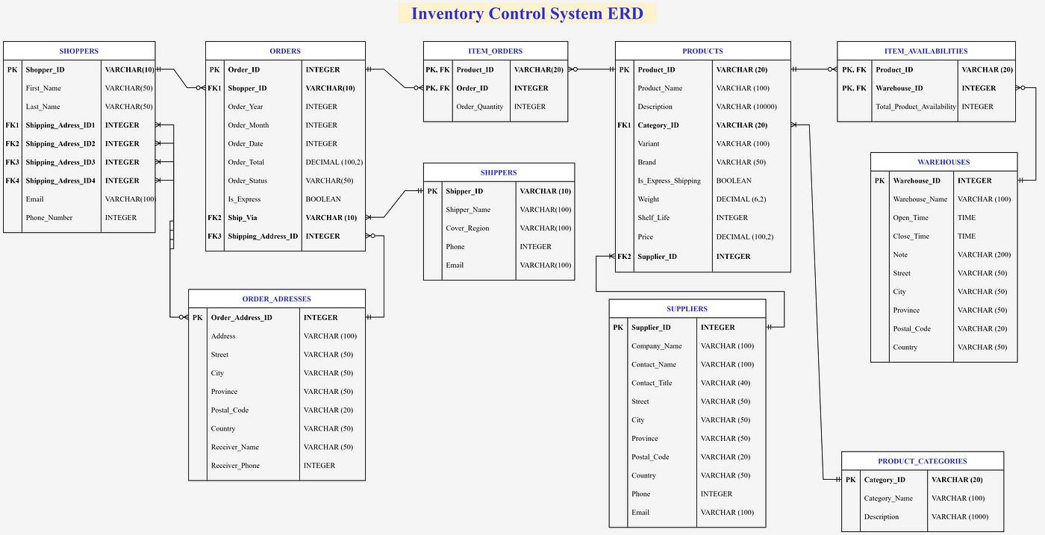

1. Movements of products with their general information by quantity. The output should be sorted in descending order and only display the first and last 5 results to see which one is the best-selling and which one has bad performance among the assortments.

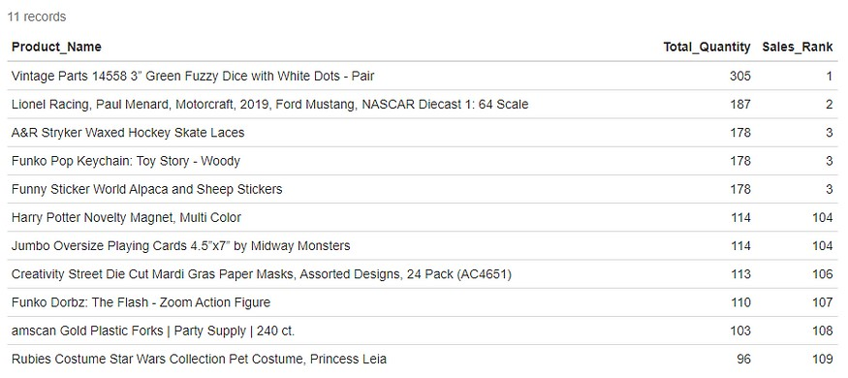

1. a. Movements of products by category by total amount with their general information. The output should be sorted in descending order to see which one is the top 3 best-selling items in each category in terms of revenue. Revenue should be counted only if the status is delivered.

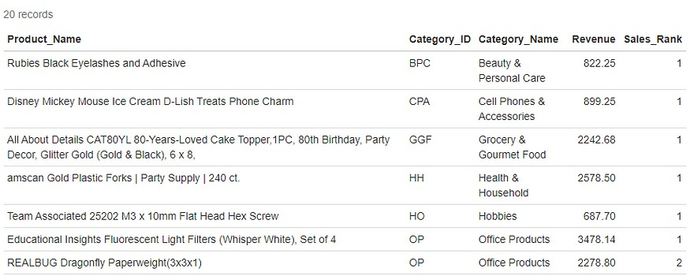

b. For the top 3 products by revenue above, the company wants to discount selling prices for them by 10% for those ranking 1, 5% for those ranking 2, and 3% for those ranking 3 by each category, the rest of products will keep the same price for next year. The price will be rounded up to 2 decimal numbers. Display only products with the price change. Revenue should be counted only if the status is delivered.

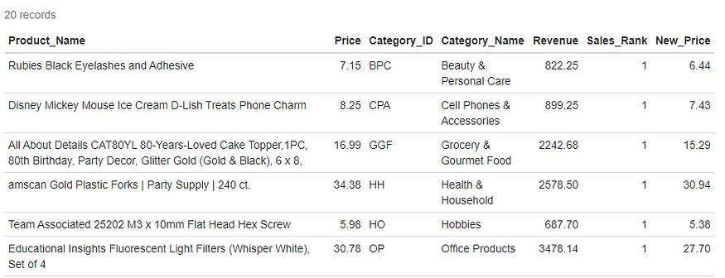

1. Customer demographic: Which countries have the most orders from the site?

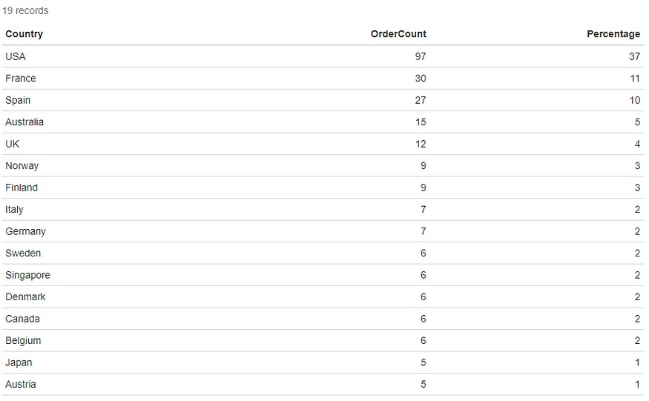

1. Customer demographic: Detail the location of the province of for top 1 country having the most orders.

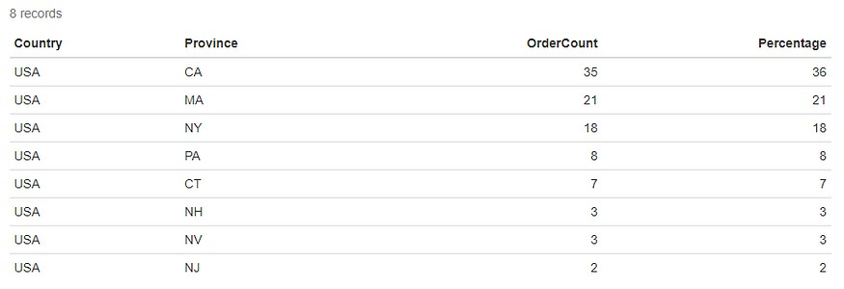

1. Operational analysis: The proportion of Order status? This is to know if the cancellation rate is less than 0.5% compared to the average of the industry.

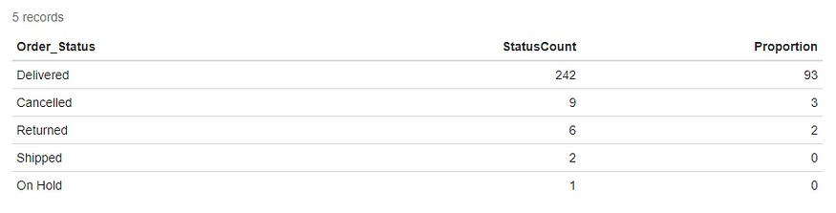

1. a. Time series analysis: Which month of the year and which date of that month does the selling peak?

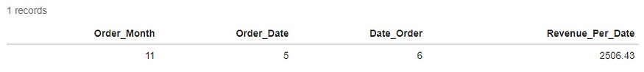

b. Time series analysis: Which quarter of the year, does the selling peak at?

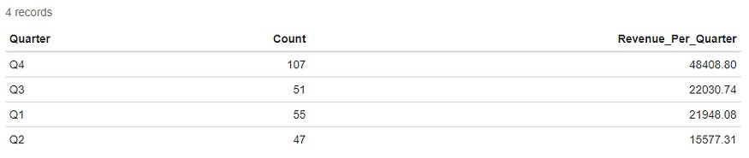

7. Total product availabilities per item and its information: name and category, sorted by descending order. Also, display stock ranking within the category and total available products.

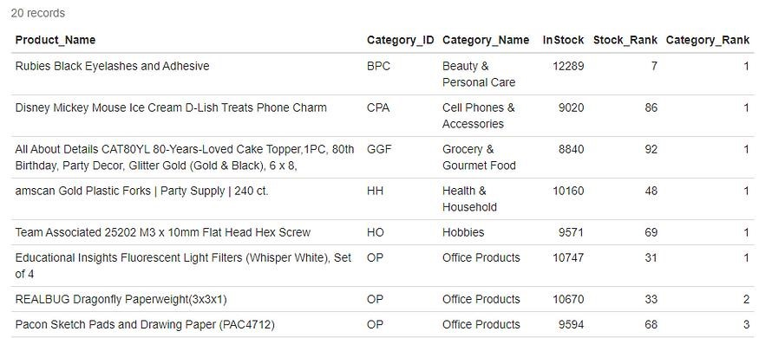

## Dashboard

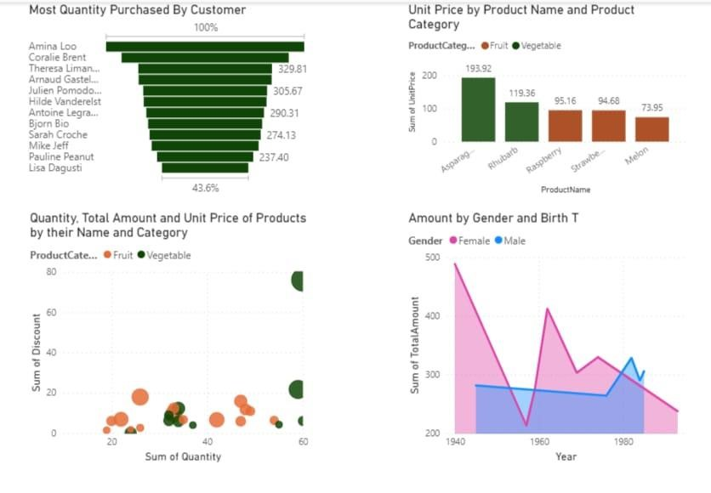

### CONCLUSION

In conclusion, the inventory and sales analysis of departmental stores plays a pivotal role in shaping their success and longevity in the ever-evolving retail landscape. Through meticulous examination of inventory levels, sales data, and customer behavior, departmental stores can unlock valuable insights that inform strategic decisions, drive operational efficiency, and ultimately, boost profitability. By harnessing the power of advanced technologies such as data analytics, artificial intelligence, and cloud computing, departmental stores can gain a deeper understanding of market trends, optimize inventory turnover, and tailor their sales strategies to meet customer demands effectively. This comprehensive approach empowers departmental stores to not only adapt to changing market dynamics but also proactively anticipate and capitalize on emerging opportunities. Furthermore, the integration of inventory and sales analysis into the core operations of departmental stores fosters a culture of continuous improvement, driving innovation and ensuring long-term viability in a fiercely competitive industry. As departmental stores navigate the complexities of modern retail, leveraging datadriven insights to inform strategic decision-making will be essential for achieving sustainable growth, enhancing customer satisfaction, and maintaining a competitive edge in the marketplace**.**

### FUTURE SCOPE

Looking ahead, the future scope of inventory and sales analysis for departmental stores is ripe with opportunities for innovation and advancement. Leveraging cutting-edge technologies such as artificial intelligence and machine learning holds immense potential for enhancing predictive analytics capabilities, enabling departmental stores to forecast consumer demand more accurately, optimize pricing strategies dynamically, and automate inventory management processes efficiently. Moreover, the integration of omnichannel retailing presents an exciting frontier, allowing departmental stores to seamlessly merge online and offline sales channels to create a cohesive shopping experience. By harnessing data analytics to personalize interactions across various touchpoints, departmental stores can drive customer engagement and foster loyalty in an increasingly competitive market. Additionally, as sustainability and ethical consumption become increasingly important to consumers, there is a growing need for departmental stores to incorporate environmental and social considerations into their inventory and sales analysis practices. Embracing blockchain technology offers opportunities to enhance transparency and traceability throughout the supply chain, improving visibility and building trust with consumers. Furthermore, the ongoing evolution of data analytics tools and platforms democratizes access to advanced analytics capabilities, empowering departmental stores of all sizes to leverage data-driven insights for operational efficiency and informed decision-making. In summary, by embracing emerging technologies, adopting customer-centric approaches, and incorporating sustainability considerations, departmental stores can position themselves for success and growth in the ever-evolving retail landscape.

### REFERENCES

<https://medium.com/analytics-vidhya/analysis-of-bank-customers-using-dashboard-in-power-bi-a366f2b3e563>

### LINK